DEPARTMENT OF COMMUNICATION, FLORIDA STATE UNIVERSITY
Interactive and New Communication Technologies

A Proposal for a Creative Project
To Be Titled

Dress for Success: A Guide to Proper Business Attire

by

Jing Wang

To Be Submitted in Partial Fulfillment for the Degree of

MASTER'S OF SCIENCE IN MASS COMMUNICATION
WITH AN EMPHASIS IN INTERACTIVE COMMUNICATION

July 28, 2026

Approved ____________________________ Date: _________
Program Committee Chair

Approved ____________________________ Date: _________
Program Committee Member

Approved ____________________________ Date: _________
Program Committee Member

Table of Content
Table of Content 1
Executive Summary 2
Target Audience 2
Need Analysis 2
Educational Objectives 3
Creative Approach 4
Target Platform 4
Audience Analysis 5
General Demographics 5
Learner Analysis 6
Technology Assessment 7
System Requirements 7
Review of Related Media 8
Website 8
Learning Objects 10
Literature Review 11
Need to Develop Career Services for International Students 12
Cultural Difference and Experiential Learning 13
Motivational Design of Computer-Based Instruction 13
Interface Design Principles 14
Specifications for Font, Color and Navigation 16
Flowchart 17
Project Plan 18
Usability Test 19
Approach 19
Findings 21
Recommendations 25
References 27
References Used for Audience Analysis 27
References Used for Literature Review 27
References Used for Usability Test 28
Appendix 1. Storyboards 29
Appendix 2. Task List for Participants 38
Appendix 3. Facilitator Task List 39
Appendix 4. Post Test Questionnaire 40
Appendix 5. Task Performance Testing Data 43
Appendix 6. Paper Prototype Materials 45

Executive Summary
The project proposed for my Masters’ Creative Project is a self-paced instructional module to educate international students (Non Resident Alien students) at Florida State University (FSU) about how to dress properly in business settings according to the American dress codes. The subject of the module is “Dress for Success: A Guide to Proper Business Attire.” This is a non-profit project. The potential client for the module is the FSU Career Center and it is suggested that the module be put on the Career Center website once completed to ensure easy access for its audience.

Target Audience
The primary audience of the module will be the 1293 non resident alien students at FSU, which makes up 3.2% of the total student enrollment in Fall 2006. Secondary audience will include any student at FSU who are interested in learning about business dress codes.

Need Analysis
The Florida State University Career Center offers four general services: Advising and Career Information; Internship and Cooperative Education; Employment and Post-Graduate Education; and Technology Research and Development. The Career Center Library provides books and videos related to different career issues, such as career planning, job hunting skills, employer information resources and so on. However, references regarding business dress codes are very scarce and hard to find in the Career Center. There are two 15-minute online workshops on the Career Center website that touch a little upon business attire and business etiquette. Both workshops feature a talking head accompanied with PowerPoint slides. Very few examples or illustrations are provided to motivate learning or facilitate transfer. The library also provides two short video series of “Where Have All the Dress Rules Gone,” which provides information on formal corporate dressing style, and can only be watched inside the Career Center Library facility. The links of other internet resources provided on the Career Center website are not particularly helpful either.
International students, especially those who are from Asia, usually have limited knowledge about western dress codes. Improper dressing will not only result in discomfort and inconvenience in their everyday life; but also influence their job hunting results and career advancement in the United States. Therefore, it would be very helpful if the Career Center can provide international students with a reference on proper dress guidelines that they can consult whenever they need to.
Based on the discussion above, there is an obvious gap between what is needed and what is actually provided. The purpose of the module is to bridge the gap by providing international students with business attire guidelines.

Educational Objectives
After taking the module, students will be able to:
-Understand American business dress codes.
-Name and differentiate various types of clothing and accessories used in business settings.
-Given a specific scenario, find out the dress mistakes the character makes.
-Given a specific scenario, select the piece(s) of clothing and accessories that best fit the character and the situation.

Creative Approach
The structure of the module is as follows:
Part 1. What is Proper Attire?
1.1 Interview Attire
1.2 Business Casual
1.3 Grooming Tips for Everyone
Part 2. Game time- “Dress up!” games
Learners will have total control over the pace of the module as they go through the module. They will also have the option to go back and forward, or to the main menu at any time.

Target Platform
As mentioned above, the module is designed for the FSU Career Center as a resource to educate international students. It is advised that the Career Center put the module on their website so that students can have easy access to it anytime they are connected to the internet. Besides, internet resources are usually less demanding to maintain and update that other media such as CD-ROMs.

Audience Analysis
The primary audiences of the training module are non resident alien students at Florida State University.

General Demographics
According to the FSU Office of Institutional Research, in the Fall semester of 2006, 1293 students enrolled at FSU are reported as “Non Resident Alien.” Table 1 shows the leading ten countries that send in the most international students to FSU.
Among the 1293 non resident alien students, 555 (43%) are female and 738 (57%) are male; 917 (70.1%) are pursuing graduate degrees. The average age for non resident alien students at FSU is 27.2 years old. The colleges with the most international students are shown in Table 2. Top ten majors that non resident alien students choose are listed in Table 3. (Florida State University Office of Institutional Research)
Country | Non Resident Alien | Non Resident Alien | Total
 | Female | Male
CHINA | 102 | 133 | 235
REPUBLIC OF KOREA | 96 | 96 | 192
PANAMA | 71 | 120 | 191
INDIA | 40 | 61 | 101
TAIWAN | 23 | 28 | 51
TURKEY | 17 | 29 | 46
JAPAN | 23 | 15 | 38
CANADA | 16 | 18 | 34
COLOMBIA | 7 | 19 | 26
LEBANON | 10 | 16 | 26
Table 1. Fall 2006 Non Resident Alien Origin Countries (Top 10)

College | Undergraduate | Graduate | Other | Total
College of Arts & Sciences | 32 | 367 |  | 399
Undergraduate Studies | 13 |  | 174 | 187
College of Education | 8 | 154 |  | 162
College of Engineering | 30 | 118 |  | 148
College of Social Sciences | 37 | 79 |  | 116
Table 2. Fall 2006 FSU Colleges with Most Non Resident Alien Students (Top 5)

Major Name | Non Resident Alien | Non Resident Alien | Total
 | Female | Male
Physics | 15 | 61 | 76
Computer Science | 9 | 32 | 41
Electrical Engineering | 5 | 30 | 35
Sports Administration | 7 | 23 | 30
Mechanical Engineering | 2 | 27 | 29
Instructional Systems | 14 | 14 | 28
Statistics | 17 | 11 | 28
Industrial Engineering | 11 | 17 | 28
Financial Mathematics | 8 | 18 | 26
Public Administration | 6 | 19 | 25
Table 3. Fall 2006 FSU Majors with Most Non Resident Alien Students (Top 10)

Learner Analysis
A brief learner analysis is provided in Table 1 and it will serve as part of the basis for the instructional design decisions in the design phase.
Category | Learner Characteristics
Prior knowledge | Little.  International students, especially those who are from Asia or Africa, usually have limited knowledge about American dress codes.
Attitudes toward potential delivery system | Positive.  College students are early adopters and heavy uses of the Internet ⁴.
Motivation | Moderate to high.  This is a voluntary training module. The assumption is that students choose to take the training module because it is relevant and useful to learn about business attire.
Group characteristics | English as a second language.  Unfamiliar with names of clothing and accessories.
Table 4. Learner Analysis

Technology Assessment
End-users will be using either a PC or Macintosh computer to access the module. These computers will be running Windows 95/98/ 2000/Me/XP, Windows NT 3.0/2000, or Apple OS 8.5 or later.
These users may access the website from their home computer/laptop, the Florida State University libraries, or the Florida State University Career Center.

System Requirements
To access the module the user is required to have:
1. A computer running Windows 98/2000/Me/XP, Windows NT 3.0/2000, or Apple OS 8.5 or later
2. Monitor, 16 bit color, capable of 600 x 800 resolution.
3. Processor: Windows 600 MHz Intel Pentium III or equivalent Macintosh 500 MHz
PowerPC G3 processor
4. RAM: Windows/Macintosh 256 MB recommended
5. Internet connection (56Kbs or faster)
6. Adobe Flash Player 8 or 9 Plug-in

Review of Related Media
This section reviews some media on related topics.

Website
Browsing web search engines resulted in finding a few websites that included information about business attire rules in the United States.
The “Syms Dress to Achieve” (http://www.symsdress.com/index.htm) website is created to help educate college seniors about the basics of proper dress and other helpful tips to present themselves in the best possible light during job interviews.
The website is comprised of two main sections: occupational outfit and interview outfit. It provides detailed explanations of both topics through descriptive text and pictures. Examples of the attire appropriate for various occupations are also provided. The site and page design is very clear and easy to follow; interactive elements are included to enhance user experience.
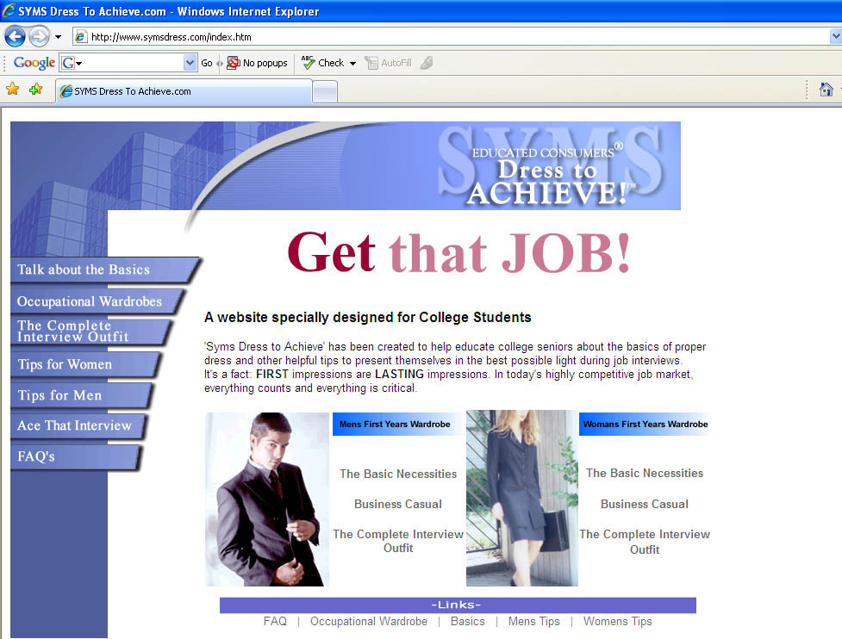
Syms Dress to Achieve Homepage Screenshot

The website of the College of Business Administration, University of Northern Iowa (http://www.cba.uni.edu/buscomm/nonverbal/dressforsuccess/index.html) provides useful and easy to understand information and pictures about corporate attire, business attire and business casual attire. The content however, is not well organized to facilitate navigation, and some of the links provided on this page are inactive. Besides, some of the wordings under the “corporate attire” section are somewhat misleading.

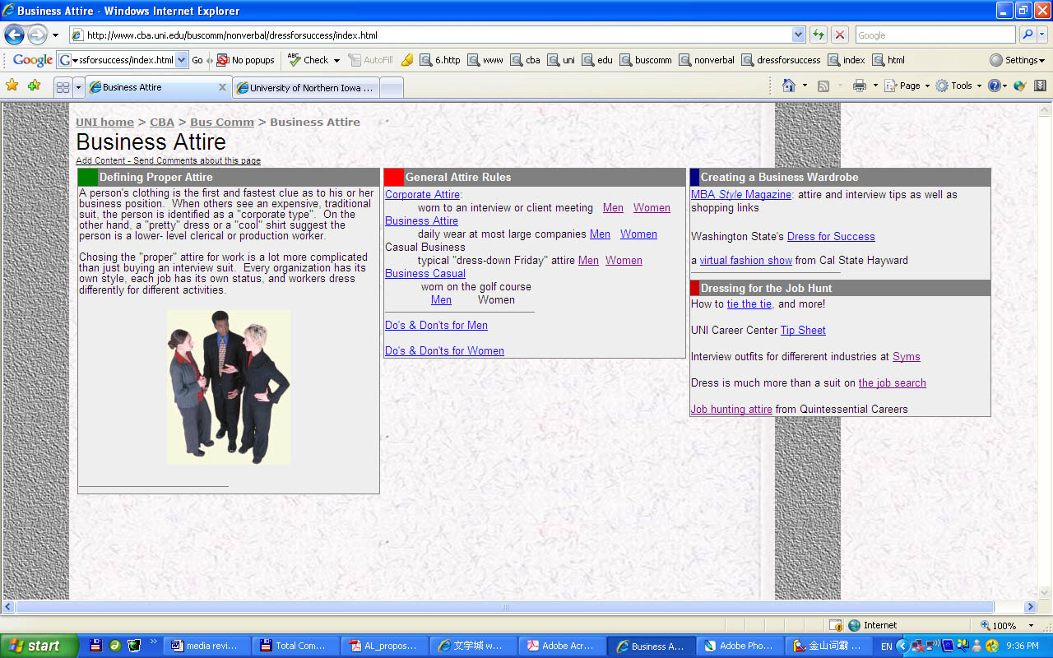
UNI College of Business Administration Website Screenshot

Learning Objects
The Wisconsin Online Resource Center is a digital library of Web-based learning resources. Two learning objects from Wisc-Online were reviewed.
Test Your Business Etiquette
The quiz (http://www.wisc-online.com/objects/index_tj.asp?objID=LDD1204) contains 12 multiple-choice questions. In each question, given a certain behavior in a real world scenario, the learner is requested to tell whether the behavior is appropriate or not under that specific circumstance. Detailed feedback is provided after the learner completes each question.
The Importance of Attire
The module (http://www.wisc-online.com/objects/index_tj.asp?objID=IAT704) introduces the basics about appropriate and inappropriate attire of instructional assistant students in community colleges. A click-and-drag game is provided at the end of the module, requesting the learner to “click on the articles of clothing that would be appropriate attire for an instructional assistant and drag them to the model.” Once an article of clothing is dragged to the model and the mouse is released, the article disappears and brief feedback such as “correct” or “incorrect” is provided on that specific article. Therefore the learner is not able to see the dress-up result and the game serves for the same purpose as that of a series of multiple choice questions asking whether each article of clothing is appropriate or not.
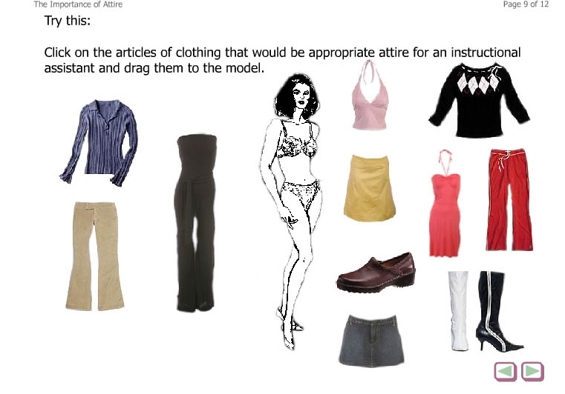
The Importance of Attire Learning Object Screenshot

Literature Review
This section summarizes the results of a literature review on related studies to (1) justify the need to develop career services exclusively for international students; (2) explore instructional strategies to teach cultural differences; (3) investigate motivational design tools of computer-based learning; and (4) survey basic interface design principles. The theories and tools included in the article will be used as guidelines for the development of a computer-based instructional module for international students at Florida State University.

Need to Develop Career Services for International Students
The increased number of international students in United States universities and colleges has created the need for the development of career services that appropriately reflect their characteristics. However, there has been little research on career services specially developed for international students.
Gibson (2005) pointed out that “culture differences, career management, and lack of knowledge and experience in the work environment of the home country are difficulties” (Gibson, 2005, p22) that international students need to overcome when pursuing a career in a foreign country. Yang et al (2002)) studied the different factors that influence international students’ career plans in the United States. These factors ranged from individualism (e.g. changes of career promotion) to collectivism (e.g. needs of home country). However, a limitation of their research is that the impact of cultural difference was not introduced as a variable in the qualitative research.
A recent research conducted by Shen and Herr (2004) focused on the career services developed to meet the needs of international students at the University of Missouri, Columbia. The authors found that when seeking employment in the United States, international students have to deal with unique concerns and vocational challenges, cultural barriers being one of them. The research result shows that it is helpful to provide online career services, such as posting a list of useful sites for career development of international students, and questions and answers frequently asked by international students on the Career Center website. The research also points out the importance to develop “more … strategies that are culturally valid for diverse groups of international students” (Shen and Herr, 2004, p211) when initiating such career services in universities.

Cultural Difference and Experiential Learning
Robertson (2004) suggested that experiential learning environment, “where the learner is personally involved in the decision-making process and thereby develops a sense of responsibility to help carry it through,” (Robertson, 2004, p68) is a good way to help the learner study cultural differences and overcome the “cultural shock.” (Robertson, 2004, p64) The key of most experiential learning models involves “the learner being placed in a demanding, authentic environment that requires a mastery of new skills, followed by an action requiring the application of these new skills” (Robertson, 2004, p68). She also points out that Internet media tools such as text, sound, static images, and video enriches learner experience in that they allow for active and responsive conversation.

Motivational Design of Computer-Based Instruction
The ARCS (Attention, Relevance, Confidence, and Satisfaction) Model of motivational design (Keller, 1987a, 1987b) provides a systematic approach to designing motivational tactics into instruction. It incorporates needs assessment based on an analysis of the target audience, provides guidance for creating and selecting motivational tactics, and follows a process that integrates instructional design and development principles. There are four dimensions of motivation: attention (A), relevance (R), confidence (C), and satisfaction (S). In a later study, Keller (1999) recommended a simplified approach to motivational design based on a review of three applications of the ARCS model to computer-based instruction. This approach uses a five by four design matrix as shown in Figure 1. The goal of the simplified approach was to ensure the teachers would identify key motivational characteristics of the learners, and then select proper media and motivational tactics for each learning task accordingly when designing computer-based instruction.

Design Factors | ARCS Categories
Design Factors | Attention | Relevance | Confidence | Satisfaction
Learner characteristics
Learning task (Learner’s attitude toward)
Medium (Learner’s attitude toward)
Courseware characteristics
Motivational tactics
Figure 1. ARCS Motivational Design Matrix - Simplified Approach
*Adapted from Keller (1999), p41.

Interface Design Principles
Jones (1995) reviewed previous literature on user interface design and provided a series of design guidelines for browsing in self-directed, computer-based learning environments. Browsing is an important concept in interface design. It allows for “the flexibility exploration” (Jones, 1995, p267) of a computer-based learning program through a variety of controls. Jones suggested that designers should allow users to control the sequence of the content through the use of topic indexes, different types of menus, maps, or user-entered search terms; and that designers should arrange the information in a “non-threatening” (Jones, 1995, p269) manner to keep users from being overwhelmed. He also suggested that feedback should be provided throughout the program to inform users of progress and delays.
Lynch and Horton (2002) seconded Jones (1995) that user control is important to graphic user interface. Bedsides, in order to facilitate user interaction, designers should provide clear navigation aids (such as icons, graphic identify schemes, and graphic or text-based overview and summary screens), allow for access to information in the fewest possible steps, avoid dead-end pages, user a metaphor that is simple, familiar and logical, and offer constant “visual or functional confirmation” (Lynch and Horton, 202, p25) of the user’s actions.

Specifications for Font, Color and Navigation

Use | Font/ Size | Color | Example
Logo | N/A | RGB 102/0/0 | 
Subtitle | Arial14 pt  Bold italic | RGB 102/0/0 | dress
Background | N/A | RGB 255/255/255
First-level navigation text | Verdana 12 pt  Bold | RGB 0/0/0 | Corporate Attire
Second-level navigation text | Verdana 12 pt  Bold  Before text indentation 1.5ch | RGB 0/0/0 | Men  Women
Buttons | Verdana 10pt | RGB 0/0/0 | Start
Content – Title | Verdana 14 pt  Bold | RGB 0/0/0 | Attire
Content –  Body text | Verdana 12 pt | RGB 0/0/0 | suit
Content –  Hyperlinks | Verdana 12 pt Underlined | RGB 51/51/204 | click
Content – pictures | Size varies | RGB varies | 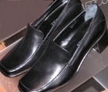  (Square)
Content – explanatory text | Verdana 10pt | RGB 0/0/0 | Example

Flowchart

Project Plan
Task | Description | Started on | Ended on
Research | -Content Research  -Audience Analysis  -Media Review | Jan 15, 2007 | April 15, 2007
Concept  development | -Structure and Content  -Layout | Jan 9, 2007 | Jan 16, 2007
Proposal  Write-up | -Official Proposal  -Approval from Committee | Jan 15, 2007 | April 15, 2007
Design | -Flowchart  -Navigation  -Storyboards | Jan 15, 2007 | April 15, 2007
Development | - Content development  - Media development | May 15, 2007 | Aug 15, 2007
1-to-1 Evaluation | -Formative evaluation with individuals from target audience  -Revise | July 15, 2007 | Aug 15, 2007
1st Draft Review | -Feedback from Committee | Sep 15, 2007 | Sep 30, 2007
Project Finalization | -Project submission after necessary revisions | Oct 30, 2007 | ____

Usability Test
This section documents the findings of a usability test of the Dress for Success Instructional Module conducted in Feb and March of 2007. The main purpose of the test was to assess the usability of the module for international students at the Florida State University.

Approach
The usability test was carried out using the paper prototype materials of part of the Dress for Success learning module.

Purpose
The primary purpose of the test was to assess the usability of the Dress for Success learning module for international students at the Florida State University. In particular, the design of the usability test was to determine the functionality of key tasks, such as the navigation and the dress-up game.

Method
The usability test was conducted with each participant individually. The author of this report served as the test facilitator. The testing included the following three phases:
Introduction
Step 1. Test facilitator greets the participant and thanks him/her for coming.
Step 2. Test facilitator briefly introduces the purpose of the test and how it works.
Step 3. Test facilitator presents a list of tasks (Appendix 2) for the participant to refer to during the test.

Testing
Step 4. Test facilitator begins to ask the participant to perform each of the four tasks in the Facilitator Task List (Appendix 3). As the participant goes through each screen, test facilitator simulates the actions of a computer and changes the elements of the paper prototype. The participant can stop at any time and make comments or ask questions.

Debriefing and Questionnaire
Step 5. After all tasks are finished, test facilitator encourages the participant to provide any comments on his/her general impression about the website and on each specific task.
Step 6. The participant is requested to finish the Post Test Questionnaire (Appendix 4).

Equipment
Paper prototypes materials, including screen layout pages and a few paper gadgets, were used to simulate the screens of the website. These materials can be found in Appendix 6.

Test Participant Profiles
A convenience sampling strategy was used to obtain participants for the usability test. The five participants chosen are all international students at the Florida State University. Participant profiles are provided in Table 2. All the participants are currently in graduate programs at FSU, and their interest in learning about American business attire is moderate to high.
# | Age | Gender | Major | Degree Pursued at FSU | Computer Literacy | Interested in Content?
1 | 26-35 | Female | Communication | Master’s Degree | Very high | Very much interested
2 | 26-35 | Male | Electrical Engineering | Doctorate Degree | Very high | Somewhat interested
3 | 18-25 | Female | Communication | Master’s Degree | High | Very much interested
4 | 26-35 | Female | Textile & Consumer Sciences | Doctorate Degree | Medium | Very much interested
5 | 26-35 | Female | Educational Psychology | Doctorate Degree | Medium | Somewhat interested
Table 2. Usability Test Participant Profiles

About the report
The report consists of two major sections. The Findings section includes data during and after the testing process. The post-test data includes both quantitative and qualitative information about the areas of navigation, screen layout and the dress up game collected by the Post Test Questionnaire. The Recommendations section offers suggestions for improvement in all these areas.

Findings

Testing Data
This section discusses the data collected during each usability test session. The participants were asked to complete the following tasks.
- In the section on Women’s Corporate Attire, find specific information on women’s blouses, shoes, and accessories.
- Go back to the main menu and start the dress-up game.
- Select Model Jen and dress her up for the situation provided in the game.
The testing data including the task performance and a summary of particular questions or comments from each participant while performing the tasks are presented in the following table.
Task # | Task Performance | Comments  (participant’s comments while performing the task)
Find specific information on Women’s business attire | 5 Completed with no problem | [Women’s business attire page]  Links on pictures not very clear. Some links are redundant.  Should expand on the same page rather than linking to a different page.
Back to main menu and start the dress-up game | 5 Completed with no problem | No comment
Select a model and dress up for the situation provided. | 3 Completed with no problem  2 Completed with explanation from test facilitator | Need more instruction on :  -what to expect when click on “start a new game”;  -whether to click on the model or the name;  -how to play the game (left click and drag the article of clothing).  Use radio buttons for different scenarios.  Should use models of different age and race, and provide profiles of the models.
Table 3. Task Performance Data -Summary
Note: see raw data in Appendix 5.

Post Test Data
This section discusses the quantitative and qualitative data collected by the Post Test Questionnaire each participant filled out at the end of the usability test session.
Quantitative Data

There are 10 items regarding different aspects of usability of the website being tested in Question 7 in the Post Test Questionnaire. Participants were asked to indicate the extent to which they agree or disagree with each of the ten items by selecting from one of the following options:
(5) Strong Agree
(4) Agree
(3) Neutral
(2) Disagree
(1) Strongly Disagree

A summary of the results for Question 7 is listed in Table 4. The highest possible average score for each item is 5; and the highest possible total score from each participant is 50.
Participant #  Item | #1 | #2 | #3 | #4 | #5 | Average Score
In general, the training module is easy to use. | 4 | 5 | 5 | 5 | 5 | 4.8
It is easy to find my way around. | 5 | 5 | 5 | 4 | 4 | 4.6
I can get to information quickly. | 5 | 3 | 5 | 5 | 5 | 4.6
It is easy to remember where to find things. | 5 | 5 | 5 | 5 | 4 | 4.8
Information is laid effectively on different screens. | 4 | 4 | 5 | 5 | 3 | 4.2
Screens have the right amount of information. | 5 | 4 | 4 | 4 | 4 | 4.2
I always felt I knew what it was possible to do next. | 5 | 4 | 5 | 2 | 4 | 4
It is clear how screen elements (e.g., scrolling lists, menu options, etc.) work. | 5 | 4 | 5 | 4 | 3 | 4.2
My mistakes were easy to correct. | 4 | 4 | 5 | 4 | 4 | 4.2
The module has a clear purpose. | 5 | 5 | 5 | 4 | 5 | 4.8
Total Score of Each Participant | 47 | 43 | 49 | 42 | 41 | 44.4
Table 4. Summary of Quantitative Data (Results of Question 7 in the Post Test Questionnaire)

Based on Table 4, the items that received the lowest and second lowest average scores are as follows:

Item Average Score

I always felt I knew what it was possible to do next. 4
Information is laid effectively on different screens. 4.2
Screens have the right amount of information. 4.2
It is clear how screen elements work. 4.2
My mistakes were easy to correct. 4.2

These scores demonstrate a problem with the navigation and the task sequence (especially for the dress-up game). The screen layout and the amount of information on each screen need to be revised based on the above qualitative data. More efforts should be devoted to help avoid and correct user mistakes. Some positive findings include that the module has a clear purpose and the overall navigation structure is clear and easy.
Qualitative Data

Questions 8 and 9 in the Post Test Questionnaire asked participants to fill in three changes they would like to make in the website and any additional comments or suggestions they have regarding improvement of the website.
A summary of the responses to questions 8 and 9 are as follows.
Screen Layout

Summary of Findings
Negative findings:
Links on the picture [women’s business attire page] were found to be unclear.
Some users did not like to click through every page, and suggested using mouse-over effects.

Raw Data- Statements by Respondents
I would like to see some mouse-over effects.
The links are unclear.

Content

Summary of Findings
Negative findings:
Lack of information on attire for different occupation.

Raw Data- Statements by Respondents
I would like to learn more about how to dress for different occupations, for example, dress up for academic jobs.

The Dress-up Game

Summary of Findings
Negative findings:
Unclear instruction about how to play; unclear wording of some links.
Lack of feedback.
Should have more models and/or more situations.

Raw Data- Statements by Respondents
Is there going to be any feedback on the selection? What if I select the wrong article of clothing? Is there going to be a beep or something?

Does “start a new game” mean to have a new model or a new scenario?

More selections of dresses, accessories and shoes

Provide profiles for models

Have more models to represent different ages, races, and etc.

What does “start a new game” mean?

I would like to pick a model that is the same image as me.

Give some more situations such as dinner party, job interview and formal conference.

Give clear instruction about each step.

Use color.

Recommendations
Based on the findings of the test, the following recommendations are made to minimize the drawbacks and to improve usability of the module.

Screen Layout
- Use mouse-over effect where applicable
- Reword some of the options/links
- Larger arrows when pointing to a picture to make the links more obvious

Content
- Add a section on how to dress for different occupations (consulting, research, academic jobs and so on)

The Game
- Add a screen with detailed instruction on “how to play”
- Add a link (a question mark) on the upper right corner on each screen of the game so that the user can call up the “how to play” page at any time
- Have more models to represent people of different ethnic groups (White, Black and Asian)
- Provide a profile for each model (gender, age, country of origin, major and son on)
- Add explanations in smaller fonts under “Start a new game” to give more options to start a new game with a different model, or with the same model but a different situation
- When an inappropriate article is selected, give a beep or some other type of warning, along with a pop up text box explaining why that specific piece is not proper for the model and/or the situation.
- Allow the user to save the results of the game

References

References Used for Audience Analysis
Anonymous. (2006). Highlights from the Open Doors 2006 Report. Retrieved at http://www.iie.org/Content/NavigationMenu/Pressroom/PressReleases/New_Enrollment_of_Foreign_Students_in_the_U_S__Climbs_in_2005_06.htm
Arenson, Karen (2006). A Decline in Foreign Students Is Reversed. Retrieved at
http://www.nytimes.com/2006/11/13/education/13students.html?ex=1321074000&en=817b2b0b0e4fa911&ei=5088&partner=rssnyt&emc=rss
Florida State University Office of Institutional Research. http://www.ir.fsu.edu/
Jones, Steve, et al. (2002). The Internet Goes to College. Retrieved at http://www.pewinternet.org/pdfs/PIP_College_Report.pdf

References Used for Literature Review
Gibson, E. (2005). The development of career services for international students. Australian Journal of Career Development. 14, 2.
Jones, M. G. (1995). Visuals for Information Access: A New Philosophy for Screen and Interface Design. Retrieved from http://www-md4.csa.com
Keller, J. M. (1987a). Strategies for Stimulating the Motivation to Learn. Performance and Instruction. 26, 8. 1–7.
Keller, J. M. (1987b). The Systematic Process of Motivational Design. Performance and Instruction. 26, 9. 1–8.
Keller, J. (1999). Using the ARCS Motivational Process in Computer-Based Instruction and Distance Education. New Directions for Teaching and Learning. 78. 39-47.
Lynch, P. J. and Horton, S. (2002). Web Style Guide: Basic Design rinciples for Creating Web Sites (2nd Ed.). New Haven, CT; Yale University Press.
Robertson, A. (2004). Process-Oriented Design: Conversational Interfaces for Global Accessibility. International Journal of Social Education. 19, 2.
Shen, Y., and Herr, E. L. (2004). Career Placement Concerns of International Graduate Students: A Qualitative Study. Journal of Career Development. 31, 1.
Yang, E., et al. (2002).Widening Our Global View: The Development of Career Counseling Services for International Students. Journal of Career Development. 28, 3.

References Used for Usability Testing
WAI Site Usability Testing Questions. http://www.w3.org/WAI/EO/Drafts/UCD/questions.html

Information & Design Usability Test Resources. http://www.infodesign.com.au/usabilityresources/default.asp

Appendix 1. Storyboards

An Instructional Module for International Students

Get Ready for Your Future

Learn about American Business Dress Codes

Start
Main Menu

The module includes three sections.

Corporate Attire

Business Casual

Dress-up Games

Please click on the above links to navigate the module in the order you wish.

Corporate Attire
Main Menu  Corporate Attire  Men  Women  Business Casual  Men  Women  Dress-up Games | Corporate attire is the most formal type of business apparel. It should be worn to interviews and other business occasions when formal wear is specified. This form of attire is also known as Business Professional.  General Guidelines:  - Be aware of the industry you are in. If customer contact is frequent and image is valuable, you will be judged more critically on your appearance.  - Even if the work environment allows jeans, or you will be working outside, wearing a suit will show you are serious about the job.  - Attire should be well-fitting, but not so noticeable as to detract attention from you as a whole.  - If in doubt, dress nicer than you think is necessary.  - Do not dress for a social event when going to an interview. Avoid dressing like you are going to a party.  - Navy, dark grey and black are the safest colors to wear to interviews. Avoid color trends and extremes. Also, wear solid colors or subtle patterns.  - Wool and wool blends are good, quality fabrics for all seasons.  Specifics for Men Specifics for Women

Women’s Corporate Attire
Main Menu  Corporate Attire  Men  Women  Business Casual  Men  Women  Dress-up Games |   Click on the picture to learn more.

Women’s Corporate Attire - Shoes
Main Menu  Corporate Attire  Men  Women  Business Casual  Men  Women  Dress-up Games | 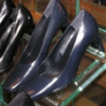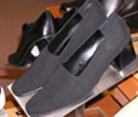  Back to women’s corporate attire
  Must have heel (No more than 2-3 inches high)
  Color should complement the suit
  No open toes

Women’s Corporate Attire – The Blouse
Main Menu  Corporate Attire  Men  Women  Business Casual  Men  Women  Dress-up Games | • Should be cotton or silk (No sheer or see through material)  • Can be a shell or a button-up blouse  • Should have a conservative neckline  • Should not be sleeveless  • Should be a solid color  Back to women’s corporate attire
   | 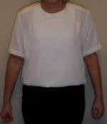

Women’s Corporate Attire - Accessories
Main Menu  Corporate Attire  Men  Women  Business Casual  Men  Women  Dress-up Games | 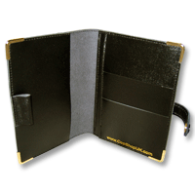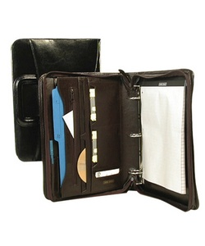  Notebook Portfolio Briefcase  Leather notebook, portfolio or briefcase. Must be large enough to hold your resume without folding it.  Back to women’s corporate attire

Dress-up Games!

How to play: Click on the articles of clothing that would be appropriate attire for the situation and drag them to the model.

Select a Model

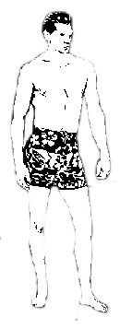

Jen Jackie

Appendix 2. Task List for Participants

Here is a list of tasks you are requested to complete in the usability test session.

- In the section on Women’s Corporate Attire, find specific information on women’s blouses, shoes, and accessories.

- Go back to the main menu and start the dress-up game.

- Select Model Jen and dress her up for the situation provided in the game.

That is all! Thank you for your participation!

Appendix 3. Facilitator Task List
Task 1
Goal | Successfully navigate the module, and get the information needed.
Inputs | Welcome page.
Steps | Click on start to get to the main menu.  Click on Corporate Attire hyperlink.  Click Specifics for Women hyperlink.  Click on different part of the pictures to learn more.
Instruction for users | In the section on Women’s Corporate Attire, find specific information on women’s blouses, shoes, and accessories.
Notes

Task 2
Goal | Successfully navigate the module.
Inputs | The finishing page of Task 1.
Steps | Click on main menu link to get to the main menu.  Click on the dress-up game link.
Instruction for users | Go back to the main menu and start the dress-up game.
Notes

Task 3
Goal | Successfully play the dress-up game as reinforcement for the content learned.
Inputs | The finishing page of Task 2.
Steps | Select the model.  Use the scrolling buttons the see different articles of clothing offered.  Click on and drag the article to the model.
Instruction for users | Select Model Jen and dress her up for the situation provided in the game.
Notes

Appendix 4. Post Test Questionnaire
Participant Number: ___
About this questionnaire
The purpose of this questionnaire is to help us gain an understanding of the people who will use the Dress for Success Training Module, and get any additional feedback or comments about the usability of the module. We will use this information to try to ensure that the Dress for Success Training Module meets the needs of the people who will be using it. All the information you provide is confidential. Your name is not stored with this questionnaire, and the information you provide will not be used for any other purpose.

1. Age (select one):
___Under 18
___18-25
___26-35
___36-45
___46-55
___Over 55

2. Gender (select one):
___Male
___Female

3. What is your major?

4. Which degree are you pursuing at FSU? (Select one):
___Bachelor’s Degree
___Master’s Degree
___Doctorate Degree

5. How do you rank your computer literacy (the degree to which you are familiar with computer operating systems and applications)? (Select one):
___Very High
___High
___Medium
___Low

6. Are you interested in learning about American business attire? (Select one):
___Very much interested
___Somewhat Interested
___Not interested
Please continue to next page…
7. Please indicate the extent to which you agree or disagree with the following statements.

 | Strongly Agree  (5) | Agree  (4) | Neutral  (3) | Disagree  (2) | Strongly  Disagree  (1)
In general, the training module is easy to use.

It is easy to find my way around.

I can get to information quickly.

It is easy to remember where to find things.

Information is layered effectively on different screens.

Screens have the right amount of information.

I always felt I knew what it was possible to do next.

It is clear how screen elements (e.g., scrolling lists, menu options, etc.) work.

My mistakes were easy to correct.

The module has a clear purpose.

Please continue to next page…

8. If there were three things you could change in the module, what would they be?

i.

ii.

iii.

9. Do you have any comments or suggestions?

Appendix 5. Task Performance Testing Data
Participant #1

Task # | Task Performance | Notes (participant’s comments while performing the task)
1 | Completed without any problem | [Women’s business attire page] The links on the pictures are not very clear. Maybe instead of going to a different page when a link is clicked, you can expand the same page to show more content.
2 | Completed without any problem | No comment
3 | Was confused whether to click on the model or the name | Wording is confusing.  Do not know what to expect when click on “start a new game.”  Maybe should use radio buttons for different scenarios.

Participant #2

Task # | Task Performance | Notes (participant’s comments while performing the task)
1 | Completed without any problem | Some links are redundant.
2 | Completed without any problem | No comment
3 | Completed without any problem | Should provide profiles of the models, just to make it more real-world like.

Participant #3

Task # | Task Performance | Notes (participant’s comments while performing the task)
1 | Completed with explanation from test facilitator | [Women’s business attire page] Links on the picture unclear
2 | Completed without any problem | No comment
3 | Completed without any problem | Models of different age and race?

Participant #4

Task # | Task Performance | Notes (participant’s comments while performing the task)
1 | Completed without any problem | No comment
2 | Completed without any problem | No comment
3 | Completed with explanation from test facilitator | Do not know whether to double click or left click and drag the article of clothing.

Participant #5

Task # | Task Performance | Notes (participant’s comments while performing the task)
1 | Completed without any problem | No comment
2 | Completed without any problem | No comment
3 | Completed without any problem | Can the results be saved for future reference?

Appendix 6. Paper Prototype Materials

